College Registration System
SR | USER Requirements | GPT Results | VeriGen Results
 | The student clicks on “Register here” button on the Home Page. | 1. The system shall provide the student with the ability to click on the “Register here” button on the Home Page. | 1. The system shall provide student with the ability to click on register here button on the home page.
 | The system displays the Registration page. | 2. The system shall be able to display the Registration page when the “Register here” button is clicked. | 2. The system shall be able to display the registration page.
 | The student enters his details. | 3. The system shall provide the student with the ability to enter registration details on the Registration page. | 3. The system shall provide student with the ability to enter his details.
 | The system validates the details. | 4. The system shall be able to validate the registration details entered by the student. | 4. The system shall be able to validate the details.
 | If all the information is not filled by the student then the validation is not done. | 5. If any required registration information is not filled by the student then the system shall not perform validation. | 5. If all the information is not filled by the student then the system shall be able to do validation not.
 | The system displays “Successful validation” message to the student. | 6. If all required registration details are filled and validation is successful then the system shall display a “Successful validation” message to the student. | 6. The system shall be able to display successful validation message to the student.
 | The user must be registered. | 7. The system shall be able to register the user after successful validation of registration details. | 7. The system shall provide user with the ability to registered.
 | The user enters his login Id with password. | 8. The system shall provide the user with the ability to enter a login ID and password on the login page. | The system shall provide user with the ability to enter his login i d with password.
 | The user clicks on the confirm button. | The system shall provide the user with the ability to click on the confirm button after entering login credentials. | 8. The system shall provide user with the ability to click on the confirm button.
 | The system checks that all of the required information was entered. | 10. The system shall be able to check that all required login information has been entered. | 9. The system shall be able to check that all of the required information entered.
 | If the entered information is wrong then system asks user to reenter the details. | 12. If the entered login information is incorrect then the system shall prompt the user to reenter the login details. | 10. If the entered information is wrong then the system shall be able to be asks user to reenter details.
 | The system validates the entered information against the tables stored in the database. | 13. The system shall be able to validate the entered login information against the data stored in the database. | 11. The system shall be able to validate the entered information against the tables stored in the database.
 | The administrator must be logged in. | 18. The system shall provide the administrator with the ability to log in to the system. | 12. The system shall provide administrator with the ability to logged in.
 | The system opens a list of options. | 21. The system shall be able to display a list of options to the administrator after successful login. | 13. The system shall be able to open a list of options.
 | The administrator clicks on the manage exam options. | 22. The system shall provide the administrator with the ability to click on the manage exam options. | 14. The system shall provide administrator with the ability to click on the manage exam options.
 | From the list, He clicks on add exam papers option. | 24. The system shall provide the administrator with the ability to select the add exam papers option. | 15. From the list , information clicks on add exam papers option.
 | The system asks him to upload the papers. | 25. The system shall prompt the administrator to upload exam papers after selecting add exam papers option. | 16. The system shall be able to ask him to upload the papers.
 | The administrator uploads the paper. | 26. The system shall provide the administrator with the ability to upload exam papers. | 17. The system shall provide administrator with the ability to upload the paper.
 | The system asks to verify the uploaded papers. | 27. The system shall prompt the administrator to verify the uploaded papers before final submission. | 18. The system shall be able to ask to verify the uploaded papers.
 | The administrator verifies the paper, clicks on upload button. | - The system shall provide the administrator with the ability to verify the uploaded papers.  29. The system shall provide the administrator with the ability to click on the upload button after verification. | 19. The system shall provide administrator with the ability to verify the paper , clicks on upload button.
 | The system acknowledges by showing a message “Paper successfully uploaded”. | 30. The system shall be able to acknowledge successful upload of exam papers by displaying a “Paper successfully uploaded” message. | 20. The system shall be able to acknowledge by showing a message paper successfully uploaded.
 | The administrator must be logged in. | MISSING | 21. The system shall provide administrator with the ability to logged in.
 | The system opens a list of options. | MISSING | 22. The system shall be able to open a list of options.
 | The administrator clicks on the manage exam options. | MISSING | 23. The system shall provide administrator with the ability to click on the manage exam options.
 | From the list, He clicks on remove exam papers option. | 31. The system shall provide the administrator with the ability to select the remove exam papers option from the manage exam options. | 24. From the list , information clicks on remove exam papers option.
 | The system asks him to select the papers to be removed. | 32. The system shall prompt the administrator to select the papers to be removed. | 25. The system shall be able to ask him to select the papers to removed.
 | The administrator selects the paper. | 32. The system shall prompt the administrator to select the papers to be removed. | 26. The system shall provide administrator with the ability to select the paper.
 | The system asks administrator to confirm again. | 35. The system shall provide the administrator with the ability to confirm the removal of selected papers. | 27. The system shall be able to ask administrator to confirm again.
 | The administrator confirms. | MISSING | 28. The system shall provide administrator with the ability to confirm.
 | The system acknowledges by showing a message “Paper successfully removed”. | 37. The system shall be able to acknowledge successful removal of exam papers by displaying a “Paper successfully removed” message. | 29. The system shall be able to acknowledge by showing a message paper successfully removed.
 | The student must be logged in. | 38. The system shall provide the student with the ability to log in to the system. | 30. The system shall provide student with the ability to logged in.
 | The system opens a list of options. | 41. The system shall be able to display a list of options to the student after successful login. | 31. The system shall be able to open a list of options.
 | The student clicks on view paper option. | 42. The system shall provide the student with the ability to click on the view paper option. | 32. The system shall provide student with the ability to click on view paper option.
 | The system asks to select the subject. | 43. The system shall prompt the student to select a subject after clicking on view paper. | 33. The system shall be able to ask to select the subject.
 | If no subject is chosen then the system asks student to select a subject again. | 44. If no subject is chosen by the student then the system shall prompt the student to select a subject again. | 34. If no subject is chosen then the system shall be able to ask student to select a subject again.
 | The student selects the subject of which he wants to see the paper. | 45. The system shall provide the student with the ability to select a subject to view the paper. | 35. The system shall provide student with the ability to select the subject of which information wants to see the paper.
 | The system shows the paper. | 46. The system shall be able to display the exam paper for the selected subject to the student. | 36. The system shall be able to show the paper.
 | The student downloads the paper. | 47. The system shall provide the student with the ability to download the displayed exam paper. | 37. The system shall provide student with the ability to download the paper.
 | The administrator must be logged in. | MISSING | 38. The system shall provide administrator with the ability to logged in.
 | The system opens a list of options. | MISSING | 39. The system shall be able to open a list of options.
 | The administrator clicks on the Upload reports link. | 50. The system shall provide the administrator with the ability to upload student reports class-wise. | 40. The system shall provide administrator with the ability to click on the upload reports link.
 | The system opens upload reports page. | MISSING | 41. The system shall be able to open upload reports page.
 | The administrator uploads the reports of the students class-wise. | MISSING | 42. The system shall provide administrator with the ability to upload the reports of the students classwise.
 | The system acknowledges by showing “Reports successfully uploaded” message. | 51. The system shall be able to acknowledge successful upload of reports by displaying a “Reports successfully uploaded” message. | 43. The system shall be able to acknowledge by showing reports successfully uploaded message.
 | The student must be logged in. | MISSING | 44. The system shall provide student with the ability to logged in.
 | The system opens a list of options. | MISSING | 45. The system shall be able to open a list of options.
 | The student clicks on the View reports link. | 52. The system shall provide the student with the ability to click on the View reports link from the list of options. | 46. The system shall provide student with the ability to click on the view reports link.
 | The student enters his name with roll number. | 53. The system shall provide the student with the ability to enter name and roll number to view reports. | 47. The system shall provide student with the ability to enter his name with roll number.
 | The system verifies it. | 54. The system shall be able to verify the student’s name and roll number against the records in the database. | 48. The system shall be able to verify it.
 | If the information entered by student is incorrect then system asks him to try again. | 55. If the entered name or roll number is incorrect then the system shall prompt the student to try again. | 49. If the information entered by student is incorrect then the system shall be able to ask him to try again.
 | The system shows his report. | 56. If the entered name and roll number are correct then the system shall display the student’s report. | 50. The system shall be able to show his report.
 | The student downloads the report. | 57. The system shall provide the student with the ability to download the displayed report. | 51. The system shall provide student with the ability to download the report.
 |  | 11. If any required login information is missing then the system shall prompt the user to enter the missing information.
 |  | 14 If the entered login information is correct then the system shall grant access to the user.
 |  | 15 The system shall be able to restrict access to authenticated users only.
 |  | 16 The system shall be able to display an error message if login fails due to incorrect credentials.
 |  | 17 The system shall be able to log unsuccessful login attempts.
 |  | 19 The system shall be able to verify administrator credentials during login.
 |  | 20 If administrator credentials are valid then the system shall grant access to administrator features.
 |  | 23 The system shall be able to display exam management options to the administrator.
 |  | 33 The system shall provide the administrator with the ability to select one or more papers for removal.
 |  | 34 The system shall prompt the administrator to confirm the removal of selected papers.
 |  | 36 The system shall be able to remove the selected exam papers after confirmation.
 |  | 39 The system shall be able to verify student credentials during login.
 |  | 40 If student credentials are valid then the system shall grant access to student features.
 |  | 48 The system shall provide the administrator with the ability to click on the Upload reports link from the list of options.
 |  | 49 The system shall be able to display the upload reports page when the Upload reports link is clicked.
 |  | 58 The system shall be able to handle file upload errors and notify the administrator if the paper or report upload fails.
 |  | 59 The system shall be able to validate the format and size of uploaded exam papers and reports.
 |  | 60 If the uploaded file format or size is invalid then the system shall display an appropriate error message to the administrator.
 |  | 61 The system shall be able to prevent duplicate uploads of exam papers and reports.
 |  | 62 The system shall be able to log all upload and removal actions performed by the administrator.
 |  | 63 The system shall be able to restrict access to manage exam options, add/remove papers, and upload reports to administrators only.
 |  | 64 The system shall be able to restrict access to view paper and view reports options to students only.
 |  | 65 The system shall provide feedback to users for each successful or failed action.
 |  | 66 The system shall be able to maintain session management for logged-in users
 |  | 67 The system shall be able to timeout user sessions after a period of inactivity.
 |  | 68 The system shall be able to display an appropriate message when a session times out.
 |  | 69 The system shall be able to prevent access to restricted pages if the user is not logged in.
 |  | 70 The system shall be able to log all failed login attempts for security auditing purposes.
 |  | 71 The system shall be able to handle unexpected system errors gracefully and display a generic error message to the user.
 |  | 72 The system shall be able to ensure that only one user session is active per user account at a time.
 |  | 73 The system shall be able to provide a logout option for all users.
 |  | 74 The system shall be able to confirm with the user before logging out.
 |  | 75 The system shall be able to redirect users to the login page after logout.
 |  | 66 The system shall be able to maintain session management for logged-in users
 |  | 67 The system shall be able to timeout user sessions after a period of inactivity.
 |  | 68 The system shall be able to display an appropriate message when a session times out.
 |  | 69 The system shall be able to prevent access to restricted pages if the user is not logged in.
 |  | 70 The system shall be able to log all failed login attempts for security auditing purposes.
 |  | 71 The system shall be able to handle unexpected system errors gracefully and display a generic error message to the user.
 |  | 72 The system shall be able to ensure that only one user session is active per user account at a time.
 |  | 73 The system shall be able to provide a logout option for all users.
 |  | 74 The system shall be able to confirm with the user before logging out.
 |  | 75 The system shall be able to redirect users to the login page after logout.

Class Diagram (GPT)
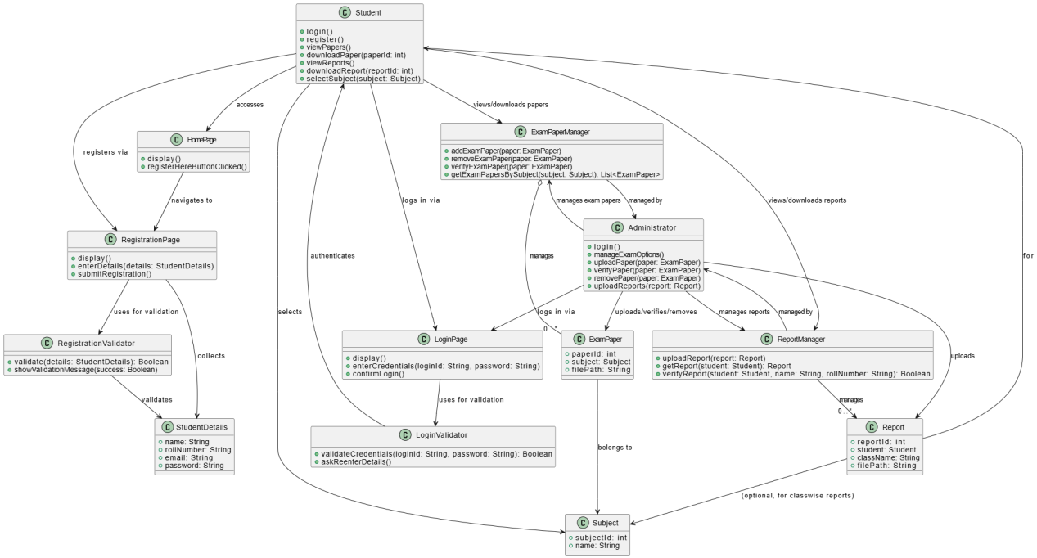

Class Diagram (VeriGen)

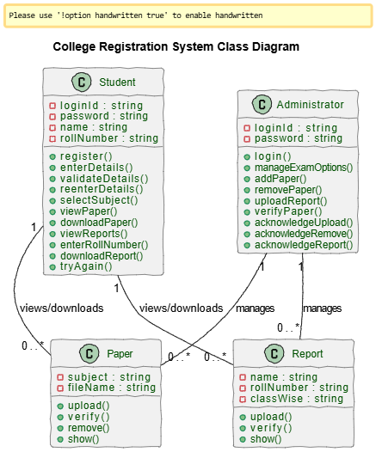

Sequence Diagram (VeriGen)

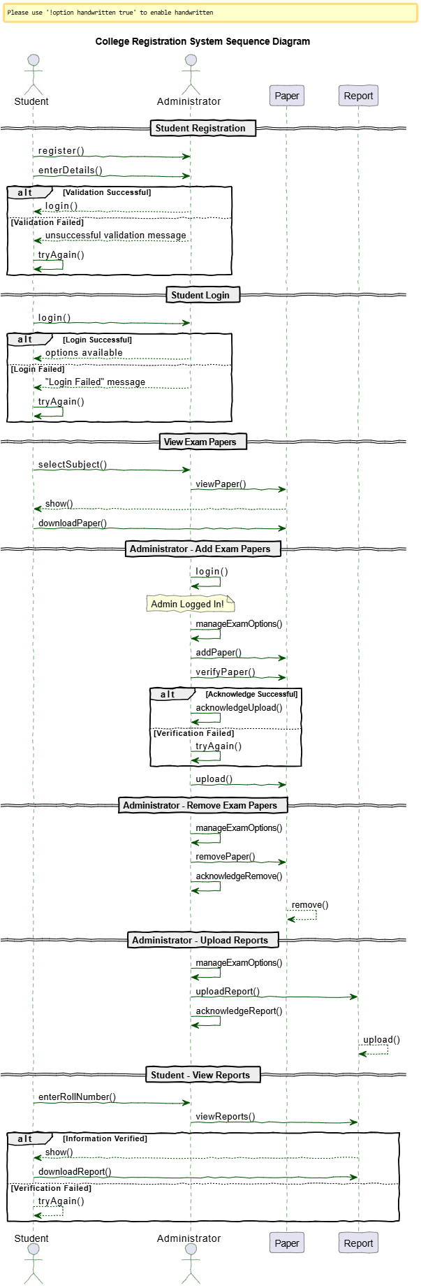

Sequence Diagram (GPT)

